1. Felix (Stray Kids) Fanart

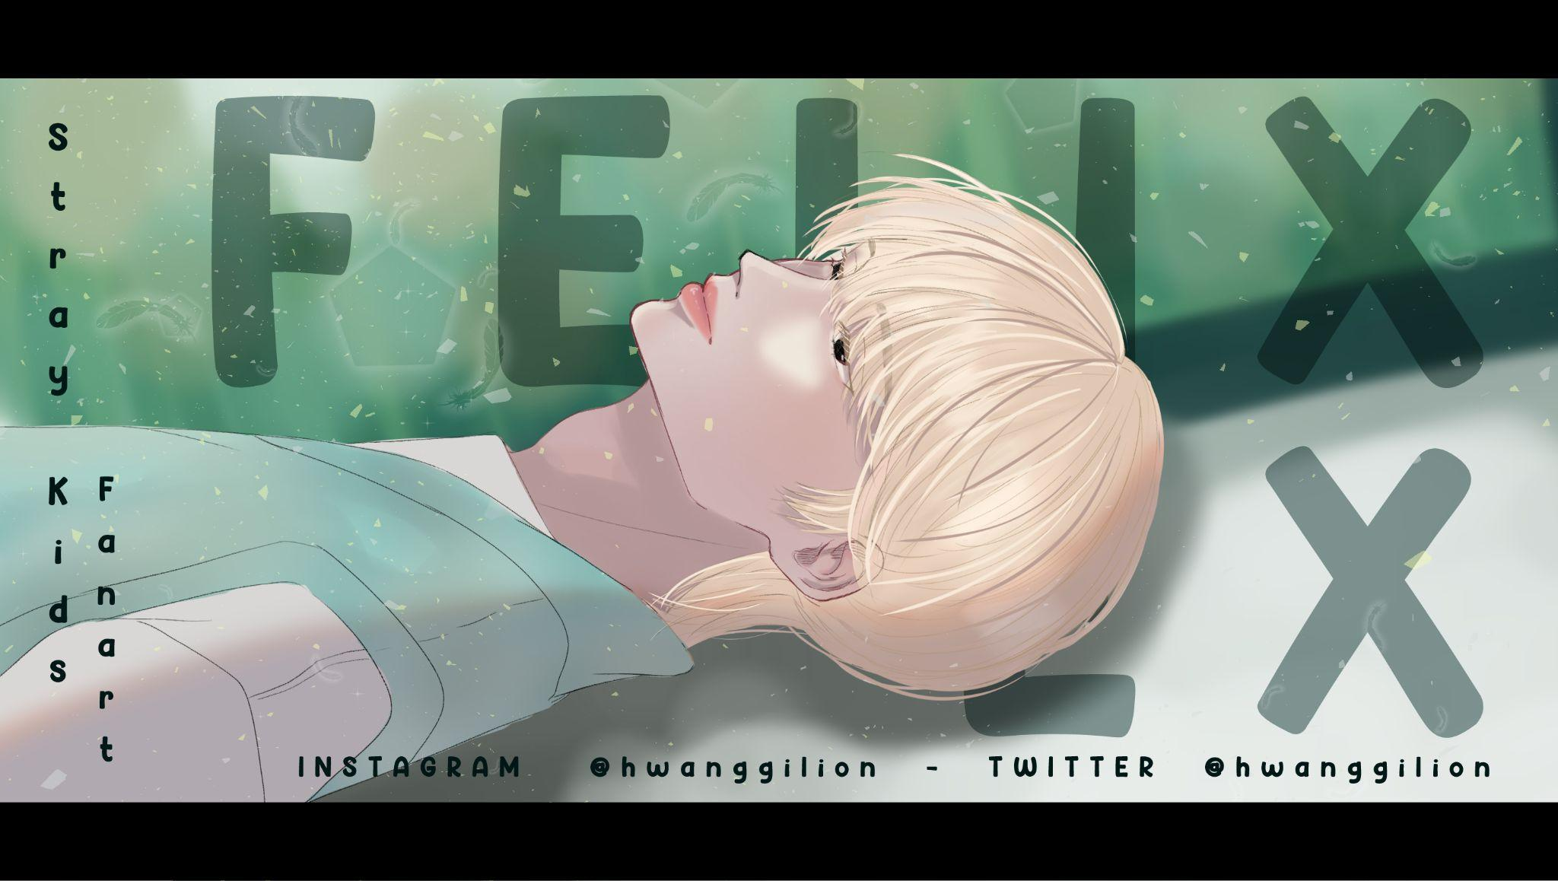

2. First Digital Art

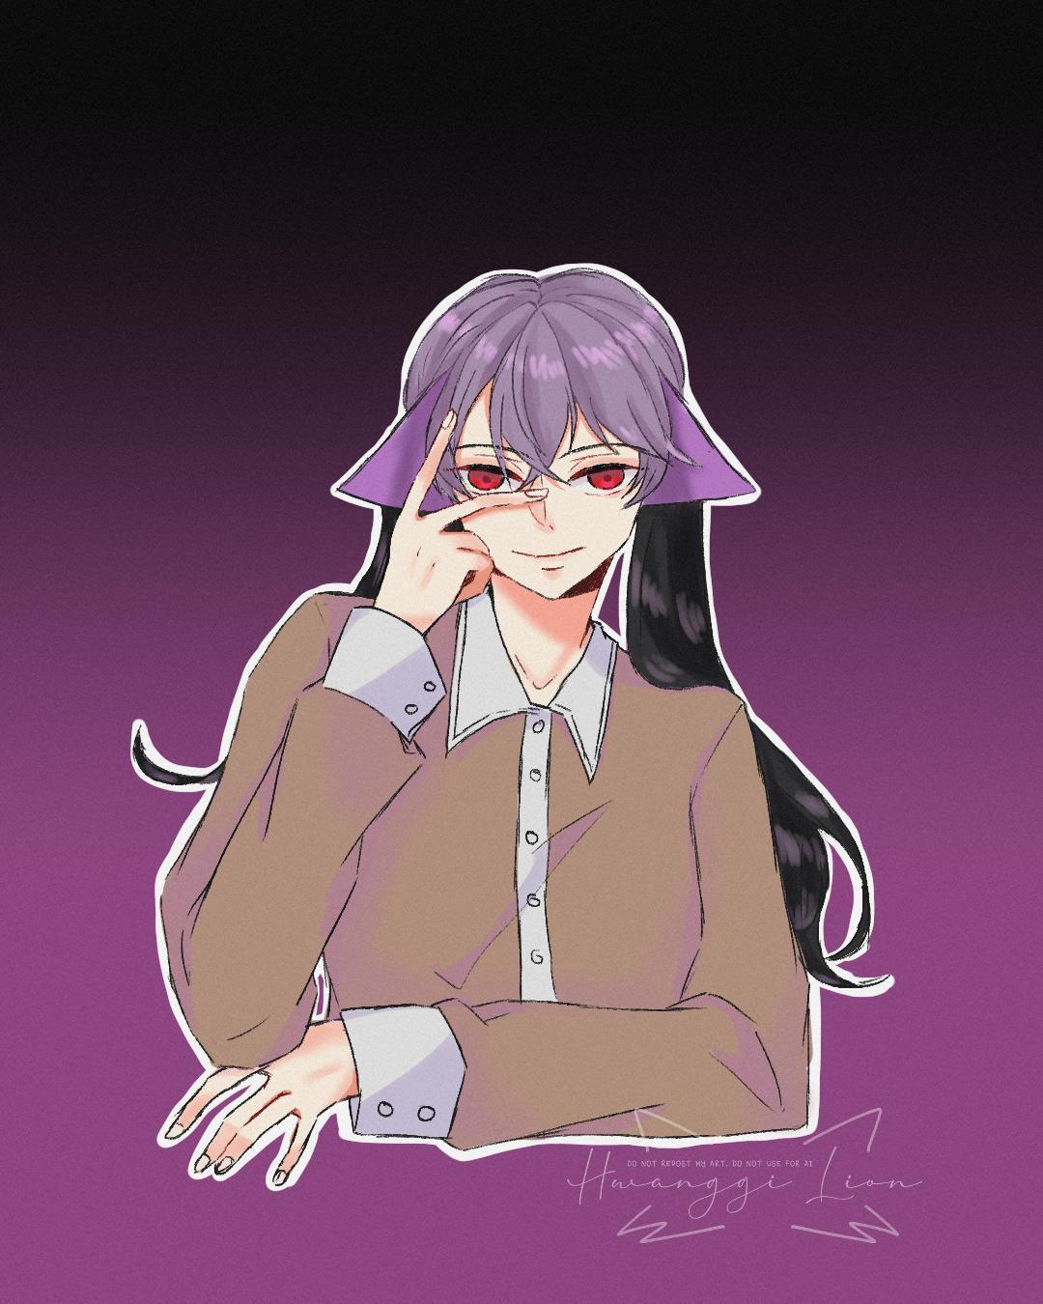

3. Hanif Indera

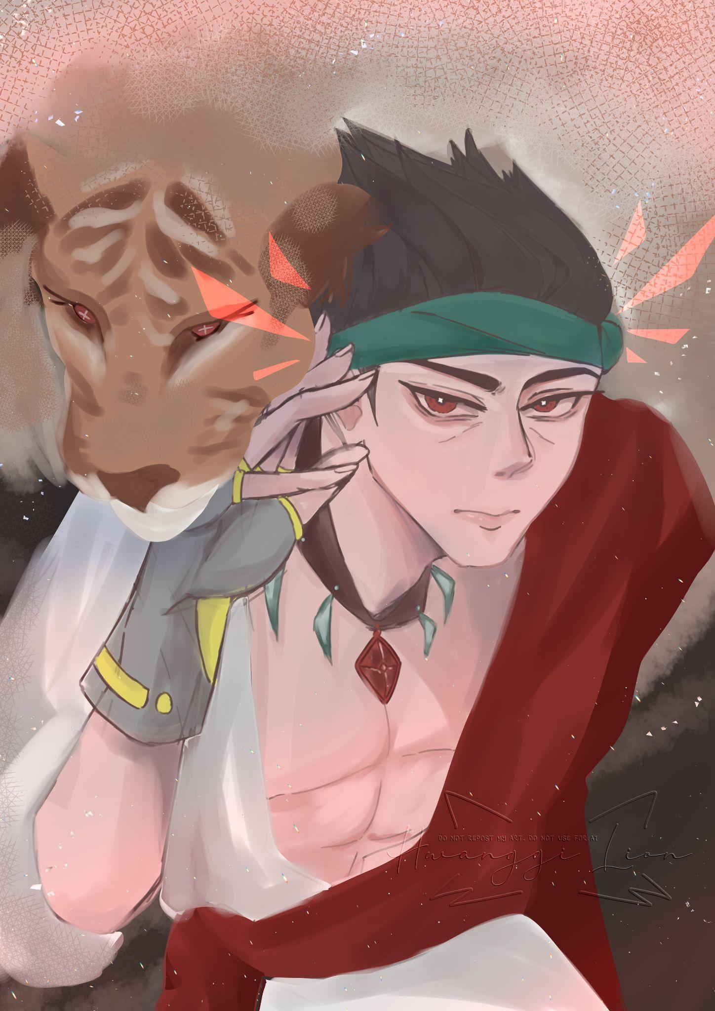

4. Eyes deceive the world

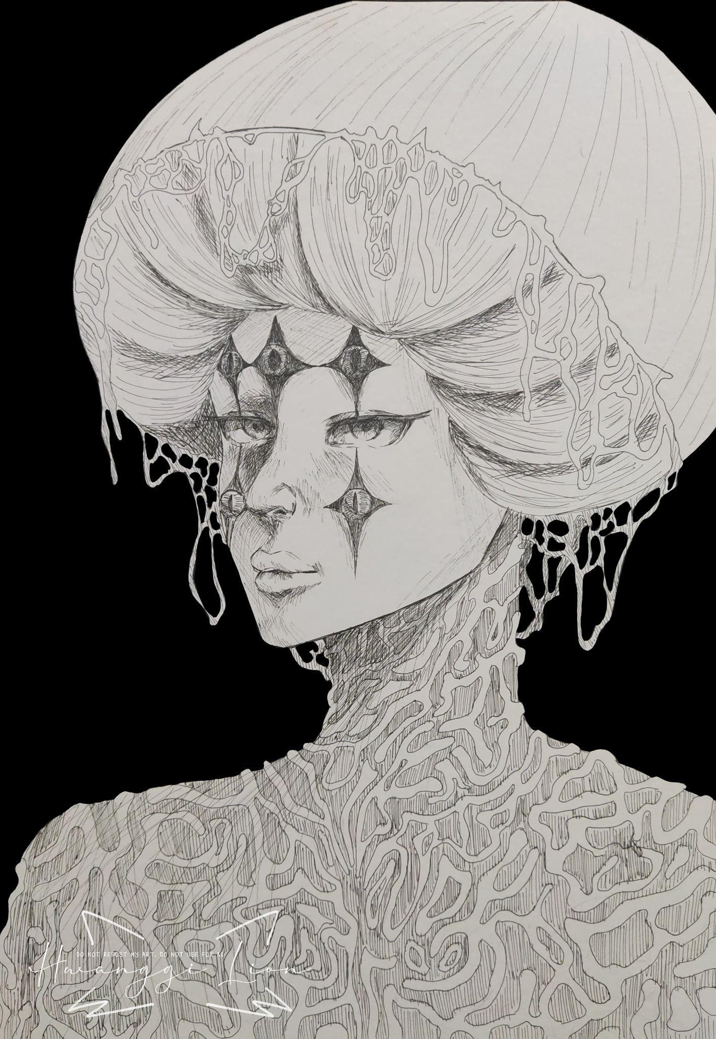

5. Sons of Lady Viviane

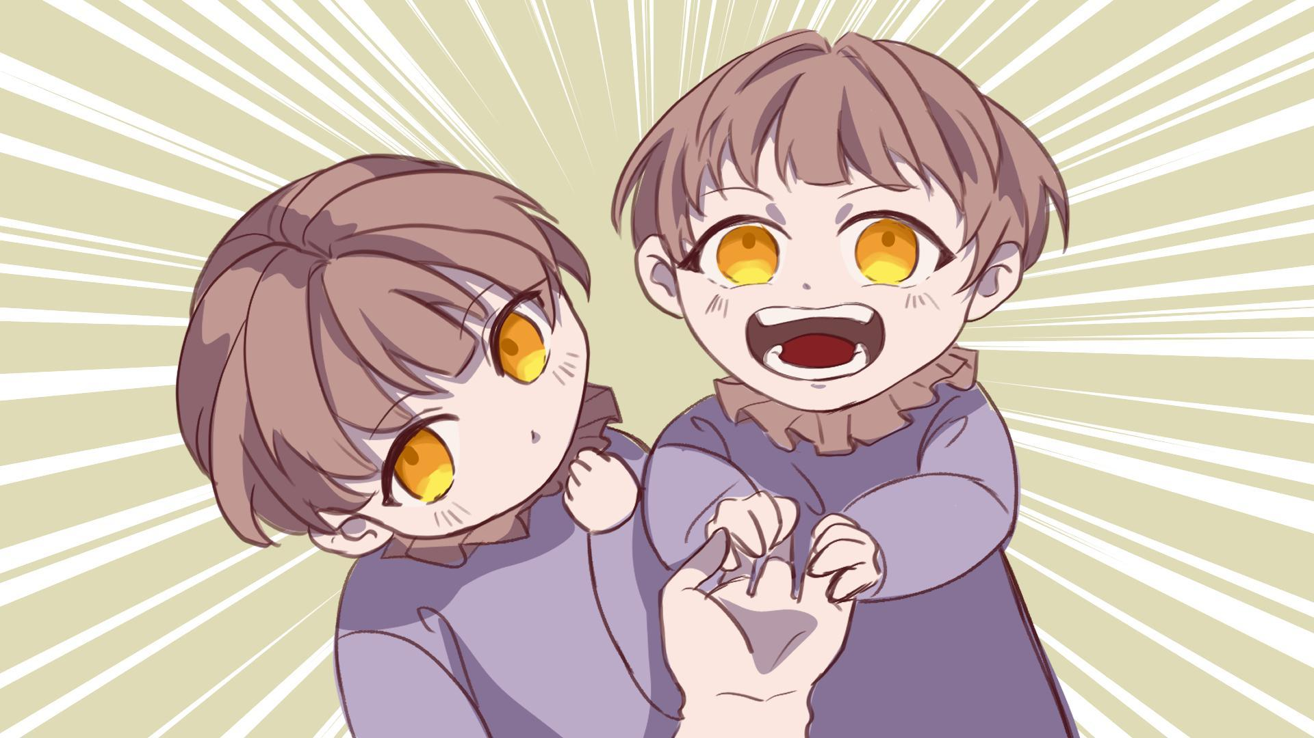

6. Random

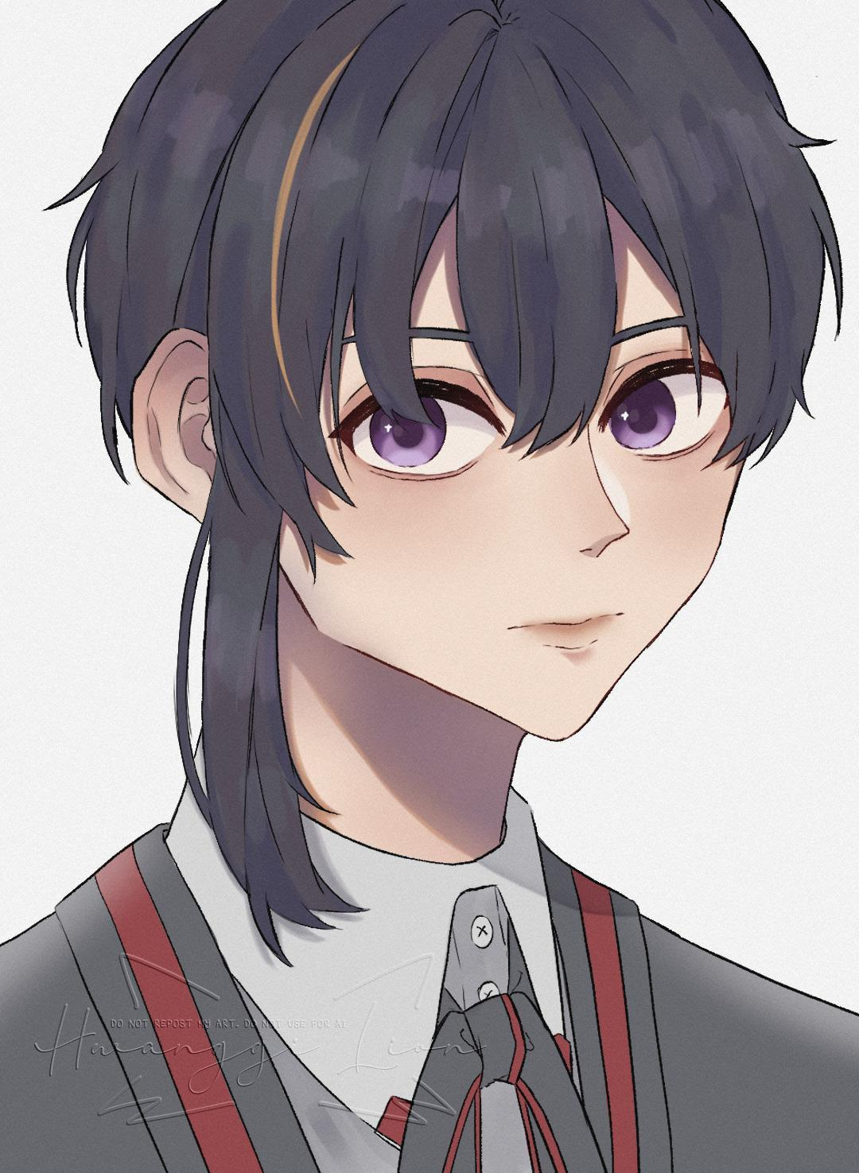

7. The Forest

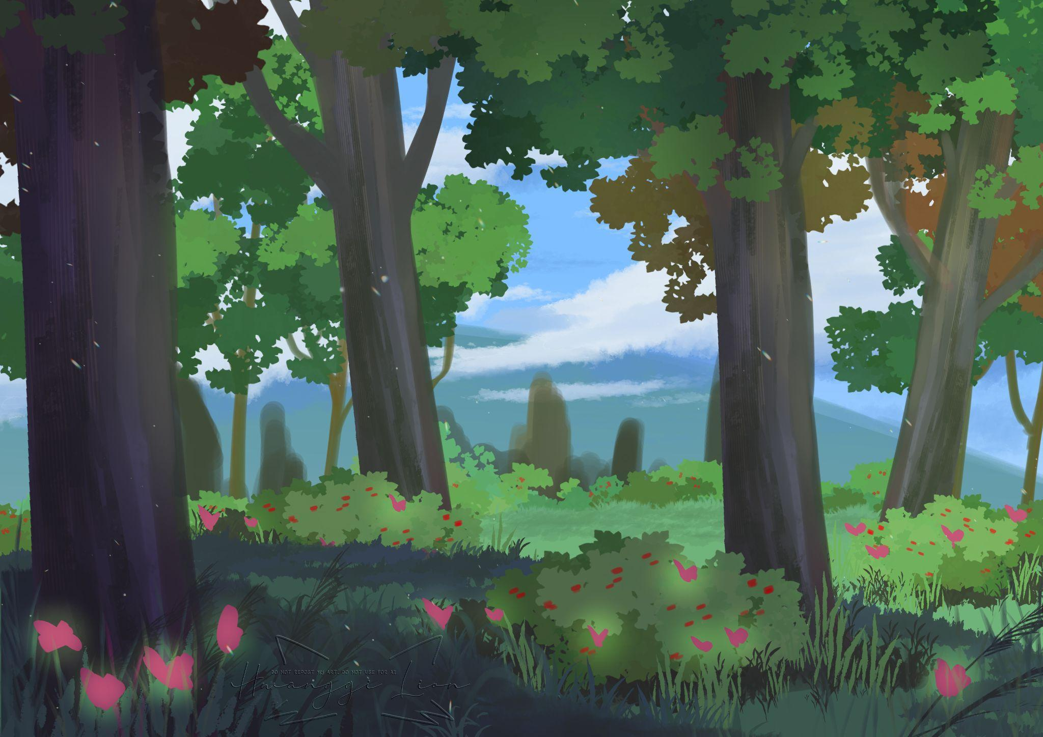

8. Jingyuan HSR Sketch

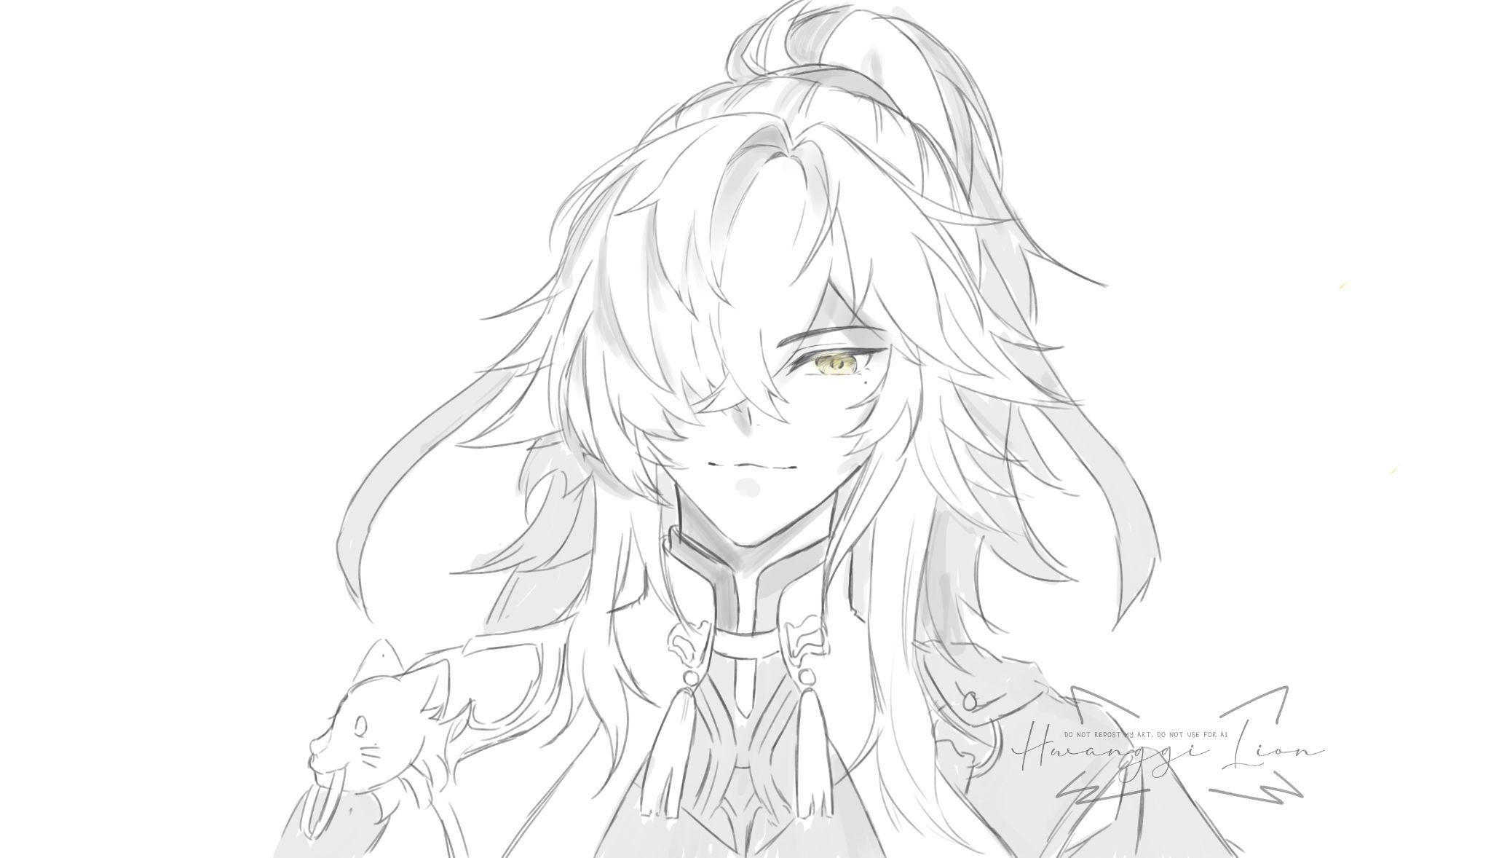

Name

Fatin Nur Amyla bt Wan Hussin

Nickname

Hwanggi

Quote

-It is the end.

Bio

Known as "Amy" by her colleagues but referred to as "Hwanggi" by the media, Amy began learning about art when she started drawing human anatomy during Biology class in high school. She discovered that art is not only a form of expression but can be used for virtually anything. She believes that art is not just about practice, but also about passion.

Social Media

Instagram

@hwanggilion

Email

[hwanggilion@gmail.com](mailto:hwanggilion@gmail.com)

X

@hwanggilion